Software Requirements Specification

for

<Shining Application >

Version 1.0 approved

Prepared by < Aamal Kmail , Dima Abu Jaber , Ansam Jawabreh , Abeer Hanaysheh >

<Arab American University >

<3/2/2022>

Table of Contents

Table of Contents ii

1. Introduction 4

1.1 Purpose 4

1.2 Document Conventions 4

1.3 Project Scope 4

1.4 References 4

1.5 Overview 5

2. Overall Description 5

2.1 Product Perspective 5

2.2 Product Functions 7

Use cases diagram (figure 2&3) : 7

2.3 User Classes and Characteristics 9

2.4 Operating Environment 9

2.5 Design and Implementation Constraints 10

2.6 User Documentation 10

2.7 Assumptions and Dependencies 10

3. System Features (Functional Requirements) 11

3.1 Order jewelry pieces 11

3.1.1 Description 11

3.1.2 Stimulus/Response Sequences 11

3.1.3 Functional Requirements 12

3.1.4 Detailed Use cases description: 12

3.2 View jewelry pieces 14

3.2.1 Description 14

3.2.2 Stimulus/Response Sequences 14

3.2.3 Functional Requirements 15

3.2.4 Detailed Use cases description: 15

3.3 Search for jewelry pieces 17

3.3.1 Description 17

3.3.2 Stimulus/Response Sequences 17

3.3.3 Functional Requirements 17

3.3.4 Detailed Use cases description: 17

3.4 Payment methods: 19

3.4.1 Stimulus/Response Sequences 19

3.4.2 Functional Requirements 19

3.4.3 Detailed Use cases description: 20

3.5 Delivery process 21

3.5.1 Description 21

3.5.2 Stimulus/Response Sequences 21

3.5.3 Functional Requirements 22

3.5.4 Detailed Use cases description: 22

3.6 Update ,Delete, Modify pieces 23

3.6.1 Description 23

3.6.2 Stimulus/Response Sequences 23

3.6.3 Functional Requirements 24

3.6.4 Detailed Use cases description: 24

4. Data Requirements 26

4.1 Logical Data Model 26

4.2 Reports 28

5. External Interface Requirements 29

5.1 User Interfaces 29

5.2 Software Interfaces 29

5.3 Hardware Interfaces 30

6. Quality Attributes 31

6.1 Performance Requirement: 31

6.2 Security: 31

6.3 Safety: 31

6.4 Flexibility: 32

6.5 Availability: 32

6.6 Robustness: 32

Appendix A: Glossary 32

Appendix B: Analysis Models 33

# Introduction

On many occasions we buy jewelry, but we are often in a mess and in a hurry to choose the right and the best. Also, often we do not have enough time to shop and buy as it should. In addition, in many cases, we may need a specific piece and we do not know which markets are providing it. So, we look forward to create an electronic market for gold that makes it easier for users to shop and buy easily and quickly. Reducing effort and trouble, with distinctive quality and high reliability.

## Purpose

This SRS describes the software functional and nonfunctional requirements for release 1.0 of the Jewelry Ordering System (Shining App). This document is intended to be used by the project team members that will implement and verify the correct functioning of the system. Unless otherwise noted, all requirements specified here are high priority and committed for release 1.0.

## Document Conventions

## Project Scope

The Shining application will provide an electronic environment that collects jewelry stores. The application will provide online shopping and selling service. So, in this application, we will solve these problems through creating An electronic environment that brings gold shops together. In addition to View price updates for each piece, searching about specific pieces, and shopping or buying online.

## References

Use cases:

<https://www.uml-diagrams.org/examples/online-shopping-use-case-diagram-example.html>

<https://www.youtube.com/watch?v=jV2nwDgraWQ>

<https://www.youtube.com/watch?v=NCU82pKqrE>

Functional & Nonfunctional requirements:

<https://theappsolutions.com/blog/development/functional-vs-non-functional-requirements/>

<https://mostaql.com/portfolio/312011-%D9%81%D8%A7%D8%AA%D9%88%D8%B1%D8%A9-%D9%84%D9%88%D9%86%D8%A7%D9%86-%D9%84%D9%85%D8%AA%D8%A7%D8%AC%D8%B1-%D9%85%D8%B5%D9%88%D8%BA%D8%A7%D8%AA>

## Overview

**Second section** will present a high-level overview of the product and the environment in which it will be used, the anticipated users, and known constraints, assumptions, and dependencies

**Third section** will talk about functional requirement in terms of use cases or method of operation, as

well as about the features of this system

**Fourth section** will describe various aspect of data that the system will consume as inputs or created as output

**Sixth section** will present detailed description about nonfunctional requirements

# Overall Description

Shining App will provide an electronic environment that collects jewelry stores as an android &IOS Apps. It provides buying online depends on PayPal, JawalPay and GOLD|XAU CFDs| plus 500 systems. Also, shopping online by viewing 3D pictures using 3DVeiw system. In addition to View price updates for each piece. Our App may benefit other online websites to view pieces of jewelry. This app will be used by gold and silver shops, user who wants to buy gold & silver and User who wants to see the latest models and prices. Shining App should be maintainable, usable and secure all the time for all users. We assume that the App is available all time so, if at least 300 users access to it at the same time, the App will still run correctly. Also, all information in this App must be reliable so, users can trust the system to shop or buy.

## Product Perspective

Shining App is a new system that replaces real shopping and buying jewelry, so users can buy and shop jewelries from their homes or work places. The context diagram in Figure below illustrates the external entities and system interfaces for release 1.0. The system is expected to evolve over several releases, ultimately connecting to the Internet ordering services for several local jewelry stores and authorization services. Also, we expect the spread of this application because it works on user comfort.

Context Diagram (figure1):

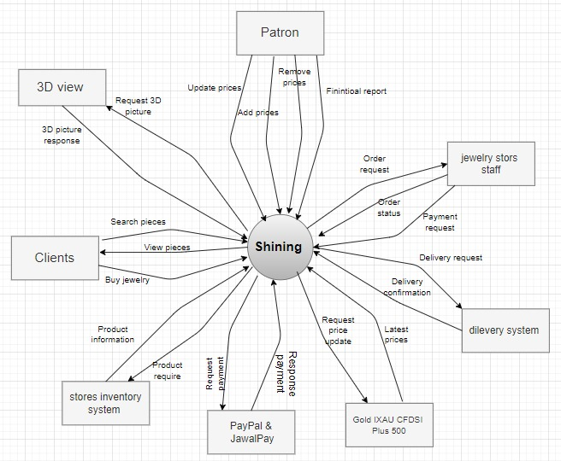

## Product Functions

|  |  |
| --- | --- |
| F1: | Collect all the gold shops in Jenin within one electronic environment via the application. |
| F2: | View the nearest gold shops located according to the demand that the customer is looking for. |
| F3: | Provides the ability to order design a specific piece of jewelry based on the user's request and view the stores that able to make that design. |
| F4: | Create, view, modify, and delete jewelry order |
| F5: | Register for order payment options |
| F6: | Provides the ability to search for a specific piece through an image. |
| F7: | It provides the feature of displaying jewelry pieces, their prices and current updates. |
| F8: | Provides the ability to buy and sell online. |
| F9: | Provides the feature of chatting with the store |

## Use cases diagram (figure 2&3) :

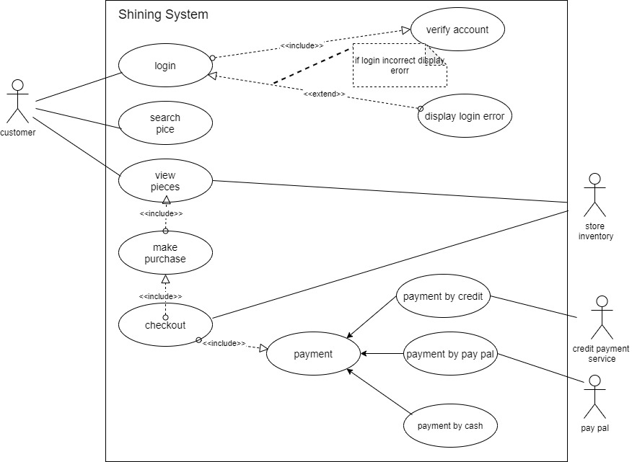

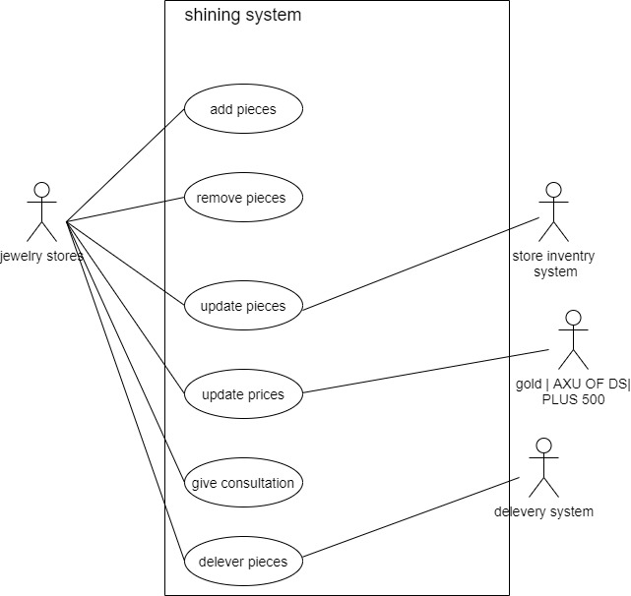

## User Classes and Characteristics

|  |  |
| --- | --- |
| User Class | Description |
| User: | This class will contain the name ,id of the user and his contact information (address, phone number, email) . The user will shop, buy and search for the piece he wants. |
| Jewelry stores: | This class will contain the names of all stores that sell the gold and silver participating in this system by dealing and associating with the database. The user will identify which stores who want to review and buy its jewelry pieces , so this class will have a great importance in reviewing the stores in it , and taking into account all its properties. |
| Jewelry pieces: | Most of the work that will be in this class, which will contain the name of jewelry pieces and their pictures, prices and features, so the user will know any data of any piece wish to buy through this class. In addition, the user can compare between several jewelry pieces in terms of its price, for example, Also, there will be the search feature via picture, which will be useful and comfortable for the user. |
| Order: | The order class will contain product and orders details. The user can order pieces and know how much he should pay for his orders. |

Finally, if we will add another class in this system, we will update this software requirement specification document.

## Operating Environment

|  |  |
| --- | --- |
| OE-1: | Shining App shall operate on Android &IOS Operating Systems |
| OE-2: | Shining application shall operate with the following Web browsers: Google Chrome., Opera Browser, and Brave Browser. |
| OE-3: | Shining application shall operate on a Cloud server, Database server, web server. |
| OE-4: | Shining application shall permit user access from an Internet connection at the user's home if he is authorized. |

## Design and Implementation Constraints

|  |  |
| --- | --- |
| CO-1: | The system shall use java programming language (object oriented)  &pl/sql database language. |
| CO-2: | *The system shall* be reliable because of the sensitivity of the buying and selling process for jewelry.(store owners require that) |
| CO-3: | *The system shall* connect and reuse the GOLD|XAU CFDs| plus 500 system to display changes in gold prices. |
| CO-4: | *The system shall* connect with the PayPal and jawal*Pay*  payment system*.* |
| CO-5: | *The system shall* connect with 3DVeiw system in order to view  The picture in 3D format. |

## User Documentation

|  |  |
| --- | --- |
| UD-1: | The system shall provide an online hierarchical and cross-linked help system in HTML that describes and illustrates all system functions. |
| UD-2: | When we finish making this system, we will deliver a formal report that describes all aspects of the project and explain it, this report can be use as a data sheet of the system. |

## Assumptions and Dependencies

|  |  |
| --- | --- |
| AS-1: | This system will be useful and effective for people interested in buying jewelry online and knowing the latest prices and models. |
| AS-2: | We expect the stores participating in the application to be highly reliable and display the pieces that they actually have. |
| AS-3: | We expect that the counseling service will be available throughout the day until 10 pm. |
| DE-1: | The success of this system depends on the agreement of jewelry to join with the database as a marketing way for them. |
| DE -2: | *The operation of the Shining depends on changes being made in the Stores Inventory System to update the availability of jewelry pieces .* |

# System Features (Functional Requirements)

## Order jewelry pieces

### Description

A verified customer may request a piece of jewelry to be delivered to a specific location or the user can visit that store that supplies the piece they want. The customer may cancel or change the meal order if it has not yet been prepared.

### Stimulus/Response Sequences

|  |  |
| --- | --- |
| **Stimulus:** | Client requests to buy an order for one or more pieces |
| **Response:** | System inquires about details of piece(s),such as payment method, available stores, delivery information. |
| **Stimulus:** | Client requests to change the order |
| **Response:** | If status is "Accepted," system allows user to edit a previous order. |
| **Stimulus:** | Client requests to cancel the order |
| **Response:** | If status is "Accepted," system allows user to cancel the order. |

### Functional Requirements

|  |  |
| --- | --- |
| **Order request :** | The system shall let a client who is logged in to the Shining System place an order for one or more pieces |
| **Order request register :** | The system shall confirm that if clients who is registered has enough money for payment |
| **Order request register.NO:** | If the client is not registered for payroll deduction, the system shall display a menu for the client if he wants to register now and continue placing an order or to place an order for pickup in the store (not for delivery for reservation purpose), or to exit from the shining system. |
| **Delivering method:** | The client shall specify whether the order is to be picked up or delivered. |
| **Delivery location:** | If the order is to be delivered, the client shall provide a valid location. |
| **Menu available:** | The system shall display updated menu of jewelry pieces |
| **Confirm order:** | When the client indicates that he is done placing orders, the system shall ask the user to select a payment method. |
| **No confirm:** | If the client does not confirm the order, the client may either edit or cancel the order. |
| **Orders Record:** | The system should permit the client to view any pieces he has ordered within the previous year. [Priority = Medium] |

### Detailed Use cases description:

|  |  |
| --- | --- |
| **Use Case ID:** | **UC-1** |
| Use case Name: | Order jewelry pieces |
| Actors: | Customer |
| Description: | A client accesses the Shining System from home via internet, optionally views the list of available pieces for a specific day, selects a piece or more, place an order to be delivered to a specified location within a specified 3 hours maximum. |
| Preconditions: | -Client is logged into shining sys.  -Client must choose the payment method by credit card or cash if he select credit card he must register for payroll deduction.  - GOLD|XAU CFDs| plus 500 system is updated every change to reflect prices jewelry pieces. |
| Postconditions: | -After the order is accepted it will be stored.  -Inventory sys is updated after confirm the order to buy it to reflect available jewelry pieces. |
| Normal Course: | 1. request the order  2. System displays list of available jewelry pieces and latest models.  3. customer selects one or more piece from list.  4. customer indicates that the order is complete.  5.System displays ordered menu of jewelry pieces, individual prices, and total price, including delivery charge.  6.customer confirms the order or requests to modify it (back to step 3).  7.customer selects the delivery location.  8.customer specifies payment method.  9.System inform the customer about the delivery time.  10.System confirms acceptance of the order.  11.System sends customer an e-mail confirming order details, price, and delivery instructions.  12.System stores order in database, sends e-mail to notify jewelry stores, sends information to the Inventory System. |
| Alternative course: | There is no alternative courses. |
| Exceptions: | 1.System informs customer that it's too late to place an order for today or for a specific time such as after the 10:00 pm.  2.  a. customer cancels the order.  b. System terminates use case.  3.customer requests to pick the order up at the selected jewelry store. skip step 7 |
| Frequency of Use: | Approximately 300 users, average of one usage per day |
| Special Requirements: | customer shall be able to cancel the order at any time prior to confirming the order.  customer shall be able to view all pieces he ordered within the previous year and repeat one of those orders as the new order, provided that all pieces are available on the list at the new order time. |
| Assumptions: | Assume that 20 percent of customers will order the latest models of jewelry(source: recent sales of jewelry stores). |
| Notes and Issues: | -If customer doesn't want to have the order delivered, the precondition requiring registration for payroll deduction is not applicable.  -Peak usage load for this use case is between 8:00 A.M. and 10:00 P.M. local time. |

## View jewelry pieces

### Description

This is one of the most important features of this system, as the user can sit on the mobile phone at home to know everything about jewelry without having to go to jewelry stores or even call any store.

### Stimulus/Response Sequences

|  |  |
| --- | --- |
| **Stimulus:** | The user request view piece of jewelry he wishes to see it |
| **Response:** | Sys views a list of jewelry categories. |

### Functional Requirements

|  |  |
| --- | --- |
| **View request:** | The system shall let a client who is logged in to the Shining System browse list of available jewelry pieces |
| **Up to date :** | The system shall provide the latest updates of jewelry pieces |

### Detailed Use cases description:

|  |  |
| --- | --- |
| **Use Case ID:** | **UC-2** |
| Use case Name: | View jewelry pieces |
| Actors: | Customer ,3D views |
| Description: | A client accesses the Shining System from home via internet. The system view a list of parts available within the application and thus allows the user to browse them. |
| Preconditions: | -Client is logged into shining sys.  -Inventory sys is updated before viewing process to reflect available jewelry pieces.  - GOLD|XAU CFDs| plus 500 system is updated continuously to reflect prices jewelry pieces. |
| Postconditions: | There is no postconditions |
| Normal Course: | 1. Request the view  2. Shining Sys. display updated list of jewelry pieces according to Inventory system updates.  3. System views two categories of jewelry (silver & gold)  3.1 if the customer choose the gold category the sys. views the available gold pieces.  3.2 if the customer choose the silver category the sys. views the available silver pieces.  4.then after choosing a specific piece the sys. provides option views about more details (weight ,price,3d image, size, gold karat)  6.view a user’s feedback in the selected piece  7.customer want to see the other category back to step 3. |
| Alternative course: | There is no alternative courses. |
| Exceptions: | If the customer cancel his view choice return to step1. |
| Frequency of Use: | Approximately 700 users, average of one usage per day |
| Special Requirements: | customer shall be able to insert any piece he likes in favorite list.  customer shall be able to give feedback on specific piece |
| Assumptions: | Assume that 70 percent of customers will view the silver category according of its lower price. |
| Notes and Issues: | -Peak usage load for this use case is available all time. |

## Search for jewelry pieces

### Description

This feature is one of the most important features provided by the system, where the user can search for a specific piece through an image so the sys views 3d pictures of searched piece. the sys also allow to search about specific store by entering its name to shop in.

### Stimulus/Response Sequences

|  |  |
| --- | --- |
| **Stimulus:** | The user wants to buy or see a specific jewelry store pieces. |
| **Response:** | Sys allows the user to search about specific jewelry store by entering the name of the store. |
| **Stimulus:** | The user wants to buy or to know more about specific piece or special design through its image. |
| **Response:** | Sys allows the user to search about specific jewelry piece by uploading its picture. |

### Functional Requirements

|  |  |
| --- | --- |
| **Search about store:** | The system shall allow search feature about available stores for the user if he does not want to look at all stores’ contents by entering the name of the store. |
| **Search**  **About**  **Piece:** | The system shall allow search feature about available pieces for the user if he has an image. So, he can upload this image to search about all identical or similar pieces. |
| **Find nearest:** | the system shall display the nearest stores of a searched piece. |

### Detailed Use cases description:

|  |  |
| --- | --- |
| **Use Case ID:** | **UC-3** |
| Use case Name: | Search about jewelry pieces |
| Actors: | Customer |
| Description: | A client accesses the Shining System from home via internet. The system view a search choice at the top of interface. |
| Preconditions: | -Client is logged into shining sys.  -Inventory sys is updated before viewing process to reflect available jewelry pieces.  - stores locations are specified. |
| Postconditions: | There is no postconditions |
| Normal Course: | 1. Select the search icon.  2. Shining Sys. display two search options (search about piece& search for store).  2.1 if the user choose the first option the system asks the user to upload or to take a picture of the desired piece.  2.1.1 the system views all identical or similar pieces.  2.1.2 the system views all stores contain similar design and there information.      2.2 if the user choose the second option the sys. asks the user to enter a name of the store.  2.2.1 the system views the jewelry pieces inside this store. |
| Alternative course: | There is no alternative courses. |
| Exceptions: | -If the system does not recognize the uploaded picture it inform the user to reload a clear one.  -If the system does not find a similar piece of the picture the sys. shall inform the user that his choice is not found.  -If the system does not find the store it will inform the user that this store is not included . |
| Frequency of Use: | Approximately 500 users, average of one usage per day |
| Special Requirements: | customer shall be able to request a special design if he doesn’t found it during his search  customer shall be able to search about the nearest store to it. |
| Assumptions: | Assume that 20 percent of customers will search about a specific store according to its popularity . |
| Notes and Issues: | -Peak usage load for this use case is available all time. |

## Payment methods:

Choosing payment way is a necessary feature in order to make the user comfort throw buying process by allowing him to use the method which is suitable for him.

### Stimulus/Response Sequences

|  |  |
| --- | --- |
| **Stimulus:** | The user request to buy an order |
| **Response:** | Provide payment options |

### Functional Requirements

|  |  |
| --- | --- |
| **Request buying:** | The system shall provide an option to buy online |
| **Display menu** | The system shall display a menu of payment option(cash, credit, PayPal…) |
| **Enter option details:** | The system shall request the data that is needed from the user that is dependent to his option |
| **Confirm :** | If the data is not confirmed, the system shall display a menu for the client to reenter his data or to or to exit. |

### Detailed Use cases description:

|  |  |
| --- | --- |
| **Use Case ID:** | **UC-4** |
| Use case Name: | Payment Methods |
| Actors: | Customer , PayPal System ,Credit payment service |
| Description: | A client request to buy an order. then the sys. views a list of payment options. |
| Preconditions: | -Client is logged into shining sys.  -if the user select buying online his account(bank ,PayPal) must have enough money.  - GOLD|XAU CFDs| plus 500 system is updated every change to reflect prices jewelry pieces. |
| Postconditions: | -payroll systems will deduct the price of order from user account.  -confirm the payment.  -generate a detailed report about payment operation.  -save the order in a user record . |
| Normal Course: | 1. request the payment  2. System displays list of payment options(cash ,credit, PayPal).  3. customer selects one of the options.  3.1 if the user select the first option he will pay when picking up the order  3.2 if the user select one of the last two options the system asks the user to enter his account info.  4. The System ask the user to confirm his payment operation.  5. After the user confirm payment the system will inform the user that his payment operation is completed.  6. payroll systems will deduct from the user account the total price of the order.  7.shining system will generate a report that contains payment details. |
| Alternative course: | There is no alternative courses. |
| Exceptions: | 1. if the user cancel his payment request the system will cancel the operation and return to the step 2.  2. if the user doesn’t have enough money in his account the sys. will notify user to check his account and return to step 2. |
| Frequency of Use: | Approximately 100 users, average of one usage per day |
| Special Requirements: | customer shall be able to change his option of payment. |
| Assumptions: | Assume that 10 percent of customers will pay using credit or PayPal (according to society culture). |
| Notes and Issues: | -Peak usage load for this use case is between 8:00 A.M. and 10:00 P.M. local time. |

## Delivery process

### Description

This feature is provided by the system to deliver the order to customer home saving his time and effort.

### Stimulus/Response Sequences

|  |  |
| --- | --- |
| **Stimulus:** | The user wants to pick up his order without going to stores. |
| **Response:** | Sys. provide delivery service . |

### Functional Requirements

|  |  |
| --- | --- |
| **Request delivery** | The system shall allow the feature of delivering the order |
| **Update delivery info.** | The system shall provide the possibility of changing delivery information and still up to date. |
| **Contact delivery company:** | the system shall provide delivery info. to contact with them. |

### Detailed Use cases description:

|  |  |
| --- | --- |
| **Use Case ID:** | **UC-5** |
| Use case Name: | Delivery process |
| Actors: | Customer , delivery system |
| Description: | The system provide delivery service for a client who complete his payment operation. |
| Preconditions: | -Client is logged into shining sys.  -The user complete his payment operation.  -Correct delivery information (location). |
| Postconditions: | There is no post conditions. |
| Normal Course: | 1. request the delivery  2. System asks the user to enter his delivery information(address, phone number ,email).  3.confirm the delivery information .  4. inform the store about the delivering process.  5. the store provide delivery company info. for the sys.  6. The System provide the delivery company contact information for the user.  7. the system inform the user about delivery time. |
| Alternative course: | There is no alternative courses. |
| Exceptions: | 1. if the provided user location was incorrect the system notify the user to provide the correct one.  2. if the delivery was not complete(can’t reach to the customer)  The order is saved until he contact with shining system or delivery company. |
| Frequency of Use: | Approximately 100 users, average of one usage per day |
| Special Requirements: | customer shall be able to change his delivery information. |
| Assumptions: | Assume that 80 percent of customers will use delivery service(saving time &effort). |
| Notes and Issues: | -Peak usage load for this use case is between 8:00 A.M. and 7:00 P.M. local time. |

## Update ,Delete, Modify pieces

### Description

This feature is provided by the system to jewelry stores in order to add, remove or update piece information on the app.

### Stimulus/Response Sequences

|  |  |
| --- | --- |
| **Stimulus:** | Availability of a new pieces in the store |
| **Response:** | System provide the add service . |
| **Stimulus:** | Unavailability of pieces in the store |
| **Response:** | System provide the delete service . |
| **Stimulus:** | New information or prices are changed |
| **Response:** | System provide the update service . |

### Functional Requirements

|  |  |
| --- | --- |
| **Request add:** | The system shall allow the feature of adding a new pieces |
| **Request delete:** | The system shall allow the feature of deleting an unavailable pieces |
| **Request modify:** | The system shall provide the possibility of changing pieces information and still up to date. |

### Detailed Use cases description:

|  |  |
| --- | --- |
| **Use Case ID:** | **UC-6** |
| Use case Name: | Update, delete, modify pieces |
| Actors: | Jewelry Stores |
| Description: | The system provide add, delete, modify services for the stores which registered for Shining app. |
| Preconditions: | -store is logged into shining sys.  -The stores has the authorization to change and add in the system. |
| Postconditions: | Inventory system will be updated after every process done from the store. |
| Normal Course: | 1. request the change  2. System display a menu of types of change (add, delete ,modify)  3.the store chose the desired option.  4. the system provide authorization of selected option for the store .  5. the store can add, delete modify to the selected option.  6. if the store add new pieces the sys will notify the user about them.  7. the inventory system is updated due to any change occurs. |
| Alternative course: | There is no alternative courses. |
| Exceptions: | 1. if the store made any change on pieces by mistake. It can undo the operation. |
| Frequency of Use: | Approximately 10 users, average of one usage per day |
| Special Requirements: | The system allow the store to save a record about change operations. |
| Assumptions: | Assume that 80 percent of stores will use this feature(according to make their collection up to date). |
| Notes and Issues: | -Peak usage load for this use case is available all the time. |

# Data Requirements

## Logical Data Model

Class diagram figure(4):

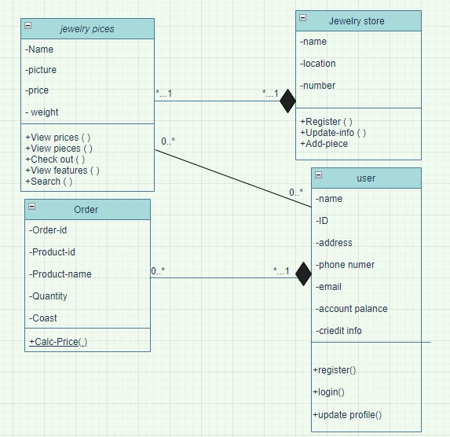

## Reports

The system will provide a report after each purchase made by the user so that the report contains the following details:

Value, weight, gold carat, price per gram, and a statement about the rest of the details shown in the figure (5) below.



# External Interface Requirements

## User Interfaces

|  |  |
| --- | --- |
| **UI-1:** | Main Interface |
| **UI-1.1:** | To allow the user to read all information about any jewelry piece which he selected. |
| **UI-1.2:** | To search for any jewelry piece by entering the store name. |
| **UI-1.3:** | To review the common pieces that similar in some characteristic specified by the user(insert picture). |
| **UI-2:** | The system shall provide a help link from each displayed HTML page to explain how to use that page. |
| **UI-3:** | The Web pages shall permit complete navigation and jewelry pieces selection using the keyboard alone, in addition to using mouse and keyboard combinations. |
| **UI-4:** | The Shining System screen displays shall conform to the Process Impact Internet Application User Interface Standard. |

## Software Interfaces

|  |  |
| --- | --- |
| **SI-1:** | **Shining inventory system** |
| **SI-1.1:** | The shining app shall transmit the quantities of jewelry pieces ordered to the shining Inventory System through a programmatic interface. |
| **SI-1.2:** | The shining shall poll the Inventory System to determine whether a requested jewelry piece is available. |
| **SI-1.3:** | When the shining Inventory System notifies the app that a specific jewelry piece is no longer available, the app shall remove it. |
| **SI-2:** | **PayPal system** |
| **SI-2.1:** | To allow a client to register for payroll deduction. |
| **SI-2.2:** | To check whether a client is registered for payroll deduction. |
| **SI-2.3:** | To submit a payment request for a purchased jewelry piece. |
| **SI-3:** | **GOLD|XAU CFDs| plus 500 system** |
| **SI-3.1:** | The shining app shall receive the prices of jewelry pieces ordered from the GOLD|XAU CFDs| plus 500 system through a programmatic interface |
| **SI-3.2:** | GOLD|XAU CFDs| plus 500 system views daily updated prices of jewelry pieces |
| **SI-4:** | **Database Interface** |
| **SI-4.1:** | To add any shop which want to join with the database. |
| **SI-4.2:** | To add, modify, and delete any information about any jewelry pieces. |
| **SI-4.3:** | To make backup of this database and check the setting of it. |
| **SI-5:** | **Program Interface** |
| **SI-5.1:** | To maintain the system if there is an error happen by modifying the code. |
| **SI-5.2:** | To update or add any component of this system. |

## Hardware Interfaces

No hardware interfaces have been identified.

# Quality Attributes

## Performance Requirement:

|  |  |
| --- | --- |
| **PE-1:** | The system shall accommodate 300 users during the peak usage time window of 8:00 A.M. to 10:00 P.M. local time, with an estimated average session duration of 5 minutes. |
| **PE-2:** | All Web pages generated by the system shall be fully downloadable in no more than 10 seconds over a 40 KBps modem connection. |
| **PE-3:** | Responses to queries shall take no longer than 7 seconds to load onto the screen after the user submits the query. |
| **PE-4:** | The system shall display confirmation messages to users within 4 seconds after the user submits information to the system. |
| **PE-5:** | The system shall display the information of any product by nice and fast way, and let the user to return to the main interface easily. |

## Security:

|  |  |
| --- | --- |
| **SE-1:** | All network transactions that involve financial information or personally identifiable information shall be encrypted. |
| **SE-2:** | The system shall permit only jewelry store staff members who are on the list of authorized Menu Managers to add or edit options. |
| **SE-3:** | The system shall permit clients to view only their own previously placed orders, not orders placed by other clients. |
| **SE-4:** | The database of this system will be secured to have right information about mobiles. |
| **SE-5:** | Users just can read the information about any product, they cannot edit or modify anything of this system. |

## Safety:

The system will reflects its ability to operate, normally or abnormally, without damage to the system's environment.

## Flexibility:

This System will be easy to learn and easy to use, also will be provide help page for all new users.

## Availability:

This System will be up to date and offer all the facilities to the users.

## Robustness:

There will not be any wrong of the information of any jewelry pieces, also the database will be backup every day.

Appendix A: Glossary

|  |  |
| --- | --- |
| Sys. | System |
| Info. | Information |
| KBps | Kilo Byte Per Second |
| bold | Important words |
| (__) | For explanation |
| inventory system | System for update available items offered by the system. |
| GOLD|XAU CFDs| plus 500 system | System for update prices of available items offered by the system. |
| PayPal system | System for used for payment operation. |

Appendix B: Analysis Models

Figure (6):

